You can collect your TENS unit from the Physiotherapy Department (level 5, Nelson Hospital) two weeks before your due date.
Reception is open between 8.00am and 4.30pm, Monday – Friday.
At this time you will be invoiced $30.00 for the hire electrode charge.
Classes for 2017 are below. Please ensure you are booked to attend.

Wednesday 01 February
01 March
05 April
03 May
07 June
05 July
02 August
06 September
04 October
01 November
06 December

Time: 11.15 – 11.45am
Venue: Maternity Meeting Room, Level 3, Nelson Hospital
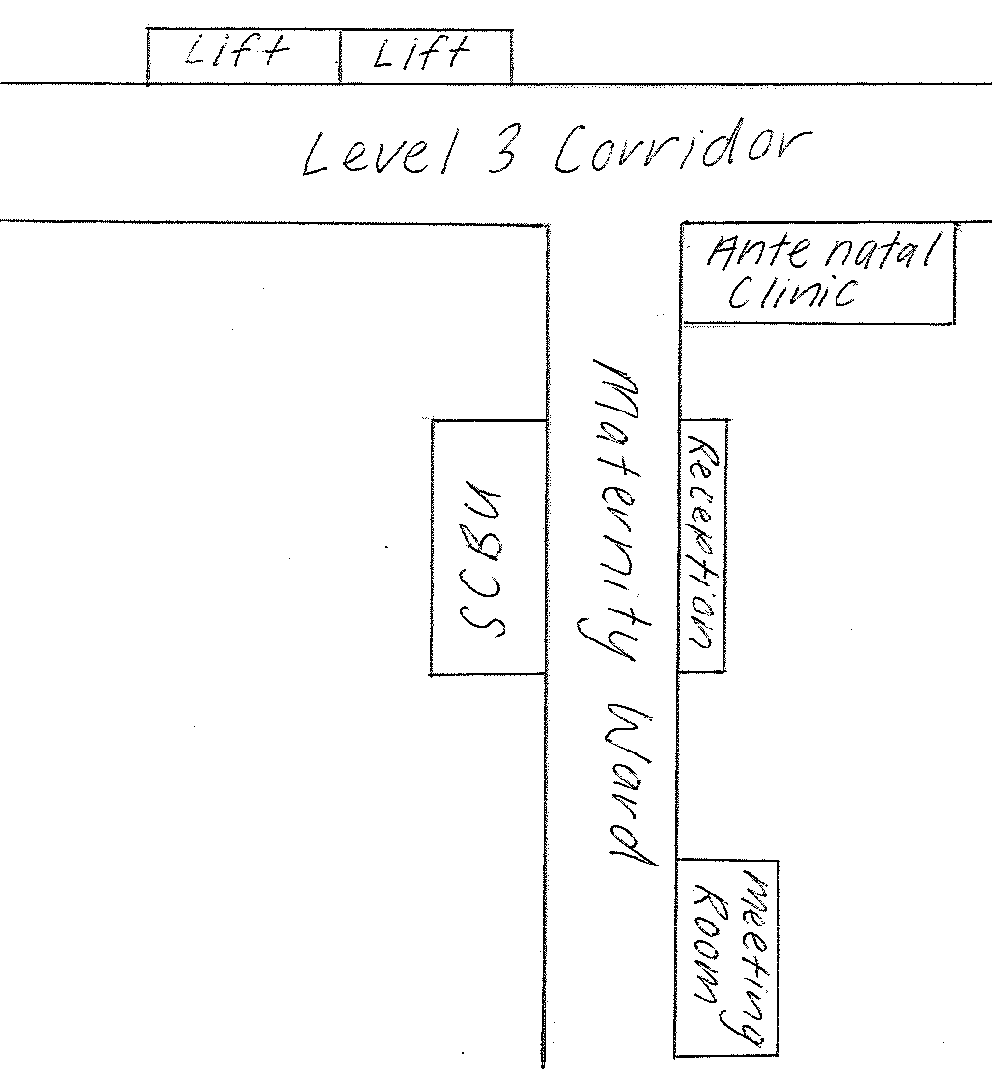




TENS
PAIN RELIEF IN LABOUR

Patient Information
Physiotherapy Department
Nelson Hospital
03 546 1801 February 2017

WHAT IS TENS?
TENS is the abbreviation for Transcutaneous (through the skin) Electrical Nerve Stimulation. It is a non-invasive medical method of providing pain relief without drugs.

The TENS unit is a small portable box which produces an electrical stimulation. It is battery powered and consists of leads and four electrodes which are placed on your back.

You are in control of the machine and can choose your own intensity.

HOW DOES IT WORK?
The exact mechanism for TENS is not known. It is believed to be attributed to two factors.
- The brain does not cope with the bombardment of this electrical signal, and the pain signal, so “shuts the gate” or overrides the pain message travelling along the nerve pathways to the brain.

- The reaction of the body to this electrical impulse is to release endorphins, which are the body’s natural pain relieving chemicals.

WHAT ARE THE BENEFITS OF USING TENS IN LABOUR?
- It is non-invasive.
- There are no known side effects to mother or baby.
- It is easy to operate either by the woman or her partner and can be stopped at any time.
- The mother can be active, mobile, and upright while using it.
- It does not limit other choices in labour.

WHEN IS IT USED?
Research shows that TENS works best when applied in early labour for a good 60 minutes. It can be used as you like, usually the intensity needs to be increased with your contractions and the special obstetric units have an adaptation and require just a push of the button to do this.

HOW IS IT USED FOR LABOUR PAINS?
Two electrodes are placed over the spine at the level of the waist. This covers the nerve supply to the uterus. Two further electrodes are placed over the sacrum. This covers the nerve supply to the deep pelvic area and tail bone.

The electrodes used are disposable and stick on and they are easily removed for the shower or bath.

WHAT DOES TENS FEEL LIKE?
The TENS machine produces a mild tingling sensation over the area the electrodes are applied.

If you can feel it – it is working.

IF I WOULD LIKE TO TRY TENS FOR LABOUR, HOW DO I GO ABOUT IT?
TENS for Labour units are available for hire from the Physiotherapy Department at Nelson Hospital for $30.00. This is the cost of the single patient use electrodes. After you have discussed using TENS with your midwife or lead maternity carer you will need to attend an education clinic anytime after 28 weeks of pregnancy. Bookings are usually made by your midwife or contacting the Physiotherapy Department Reception on 03 546 1801. You are welcome to bring along a support person with you.

Generally you will want to turn up the intensity as labour progresses. The nerves tend to get used to it or “accommodate” it and you don’t feel it as strong.

TENS should never be really uncomfortable! If it is just turn the intensity down.
5. You can move about with the TENS on but you MUST TURN OFF AND REMOVE ELECTRODES IF YOU GO IN THE WATER for a bath or shower.

6. PRECAUTIONS
- do not use if you have a pacemaker.
- do not use if you have epilepsy
- Do not place both electrodes over an area of skin which is numb – you could set too high and produce a skin rash.
- do not place over your abdomen or any other area that you have not been instructed

J:physioTFL

TENS
FOR LABOUR INSTRUCTION SHEET

Patient Information
Physiotherapy Department
Nelson Hospital
(03) 546 1801 February 2017

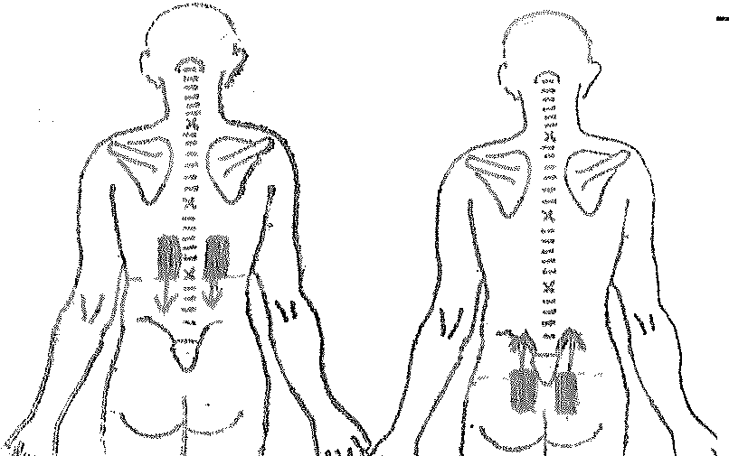

2

HOW TO PLACE ELECTRODES
Stand or sit very straight.
- Locate the thinnest part of the waist line at the side. Draw an imaginary line to the mid back. Place the lower edge of the electrodes here. Place them one finger width apart. Place tags down.
- Locate prominent bone in front of pelvis. Draw an imaginary line around to the back, and place the top of the electrodes here.
OR, locate the top of the buttock crack and place the bottom of the electrodes here. These should be two finger widths apart, using the buttock crack as the midline. Place the tags up.

POSITIONING OF ELECTRODES IS MOST IMPORTANT
Two are placed over the spine – at the level of the 10 – 12th Thoracic vertebra, which cover the nerve supply to the uterus. Two are placed over the sacrum, which covers the nerve supply to the perineum and the deeper pelvic region. See the above picture.
- Apply electrodes to clean dry skin. You may like to shower first, or wash the back with soap and water and dry well. This lowers the skins resistance and aids the transmission of the electrical pulse.

- Using the stick-on disposable electrodes, gently peel them from the protective liner and attach as instructed. Then attach the leads so that one set of leads is attached to the lower electrodes.

3. Do not apply electrodes to broken skin (any area of broken skin needs to be covered with a tiny bit of Vaseline).

- Apply TENS early in labour for the best results. When you know you are in labour put it on, and use it for 60 minutes continuously, then use as required.
Method 1 – Strong Burst between contractions. High intensity Continuous during contractions.
Method 2 – Low intensity Continuous between contractions – switch to high intensity continuous during contractions.

Setting suggestions:
Pulse width: time between the pulse switching on and off again (mSecs)
Pulse Frequency: rate of pulses, repeated every second (Hz)
Constant (N): 70 -150Hz, 150 – 250 mus.
Burst: 0.2 – 5.00Hz, 150mus

- If you are using the special obstetric unit, you will push the hand held button at the beginning of a contraction and again when it is over. Some machines increase the intensity by 10% with use of this buttons, others need to be turned up manually.

If you have a standard TENS unit, you may like to turn the intensity up over a contraction, or have someone do it for you, but you will need to give clear guidelines as to how high – only you can feel it!

