The Public Health Service is unable to accept samples from commercial operators, including property managers and real estate agents, builders, etc. The funding of sample analysis is for homeowners DIY work only.
By submitting this sample, you are acknowledging that you are not a commercial operator.

ASBESTOS SAMPLE DETAIL
Date: |  | Client Name:
Phone: |  | Mobile: |  | Email:
Address:
(Where sample taken)
 |  | Office use only Sample Number & detail
Sample Location  (e.g. flooring from kitchen, ceiling material from lounge, cladding from west side of house etc.) |  | HPO Sample No | Sample 1
 |  | HPO Sample No | Sample 2
 |  | HPO Sample No | Sample 3
 |  | HPO Sample No | Sample 4

Office use only:
HPO: | Email: | MOH Contract: | √

Instructions to Lab:
This sample has been submitted by NMPHS (by the HPO named above)
Please email the results back to the HPO only.
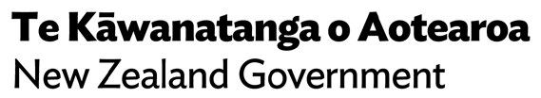
We do not require a hard copy.

